**PIZZA SALES SQL QUERIES**

1.Total Revenue:

select sum(total_price) as total_revenue from pizza_sales;

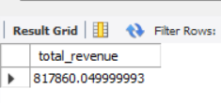

2.Average_order_value

select sum(total_price)/ count(distinct(order_id)) as Average_order_value from pizza_sales;

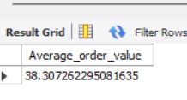

3. Total_pizza_sold

select sum(quantity) as Total_pizza_sold from pizza_sales;

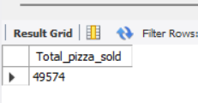

4.Total_orders

select count(distinct(order_id)) as Total_orders from pizza_sales;

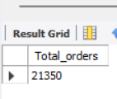

5.Average Pizzas per ordered:

SELECT SUM(quantity)/count(distinct(order_id)) as Average_Pizzas_per_ordered from pizza_sales;

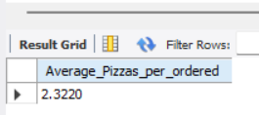

1.Daily trend total orders

select dayname(order_date) as order_day,count(distinct(order_id)) as Total_orders from pizza_sales group by dayname(order_date) order by FIELD(order_day, 'Sunday', 'Monday', 'Tuesday', 'Wednesday', 'Thursday', 'Friday', 'Saturday');

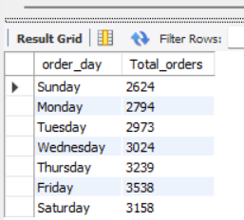

2.Hourly trend for total orders

select hour(order_time) as 'time', count(distinct(order_id))as 'Total_orders' from pizza_sales group by hour(order_time) order by time;

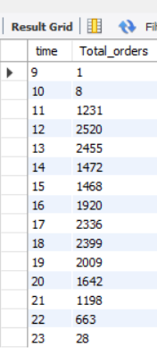

3.percentage of pizza by catageory:

select *, round((total_sales/sum(total_sales) over())*100 ) as Total_percentage from

(select pizza_category as pizza ,round (sum(total_price) )as total_sales from pizza_sales group by pizza_category order by total_sales desc) t

OR

select pizza_category as pizza ,(sum(total_price)*100/sum(sum(total_price)) over())as Total_percentage from pizza_sales group by pizza_category

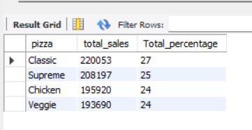

4.percentage of sales by pizza_size

select pizza_size,round(sum(total_price))as total_sales,round((sum(total_price)/sum(sum(total_price)) over())*100) as Total_percentage from pizza_sales group by pizza_size order by Total_percentage desc;

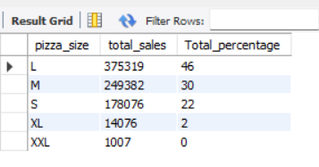

5.total pizza sold by pizza category

select pizza_category,sum(quantity )as Total_sales from pizza_sales group by pizza_category;

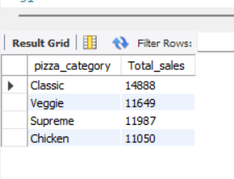

6. top5 best sellers by total pizza sold

select pizza_name ,sum(quantity)as total from pizza_sales group by pizza_name order by total desc limit 5

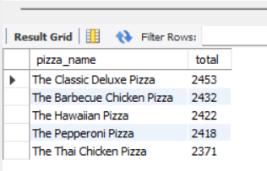

7.bottom 5 worst seller by pizza total sales

select pizza_name ,sum(quantity)as total from pizza_sales group by pizza_name order by total limit 5

